**Admin:**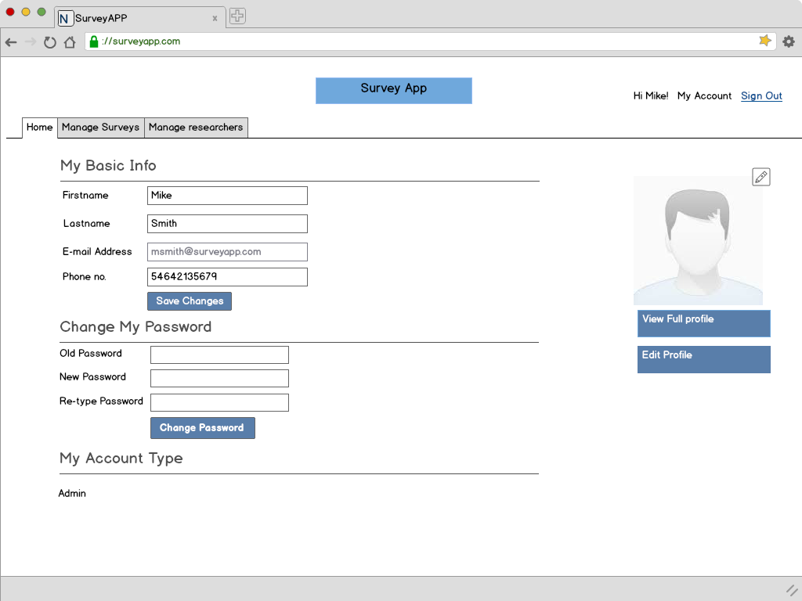

* On Login each user will be shown a **Home page** that will list out the basic information about their profile.
* They can **change their basic information** here itself or go to view/edit their full profile. However, **email id** being the sole criteria for authentication will not be editable.
* The users will also have an option to **Change Password** through this page.
* As a **security measure**, changing password will be **mandatory** for anybody logging for the first time.

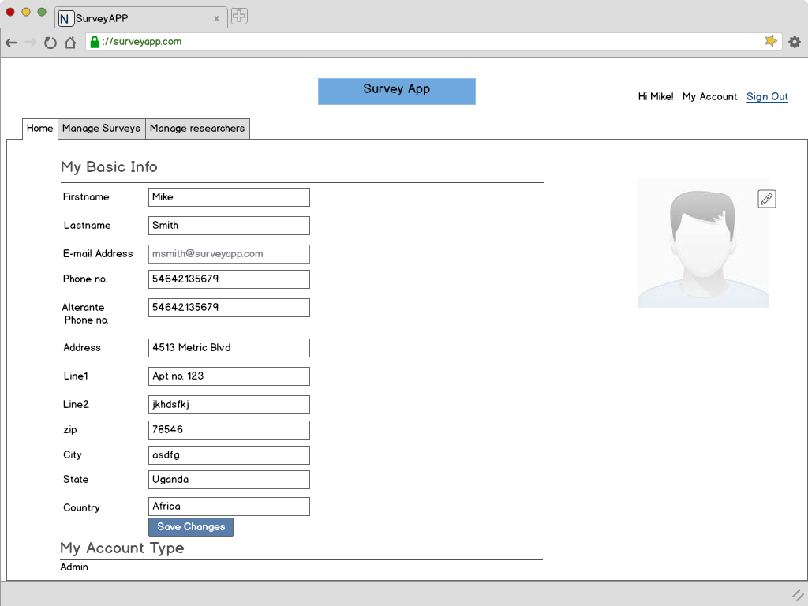

* The full profile page can be accessed via the Home tab. User can view and edit all their profile information except for the email id.

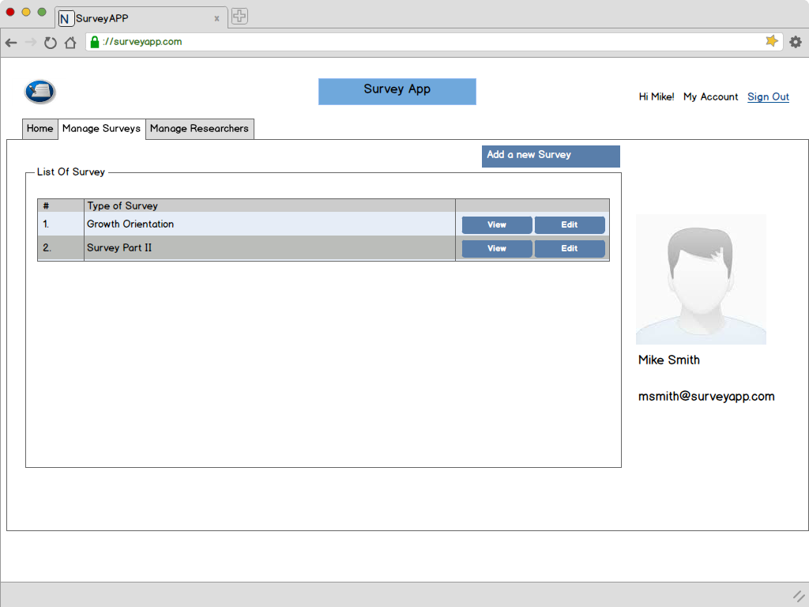

* The “**Manage Survey**” tab allows the admin to **add new surveys** that have been created in the database. These new surveys will automatically show up for the Surveyors to initiate on their mobile devices.

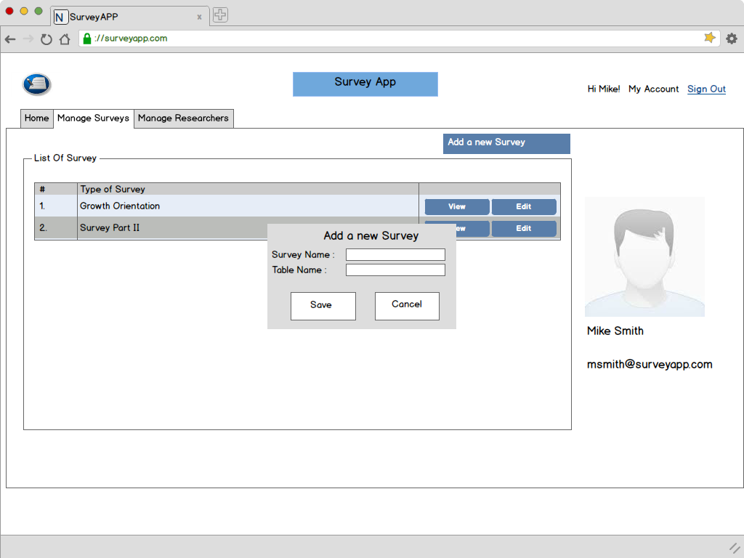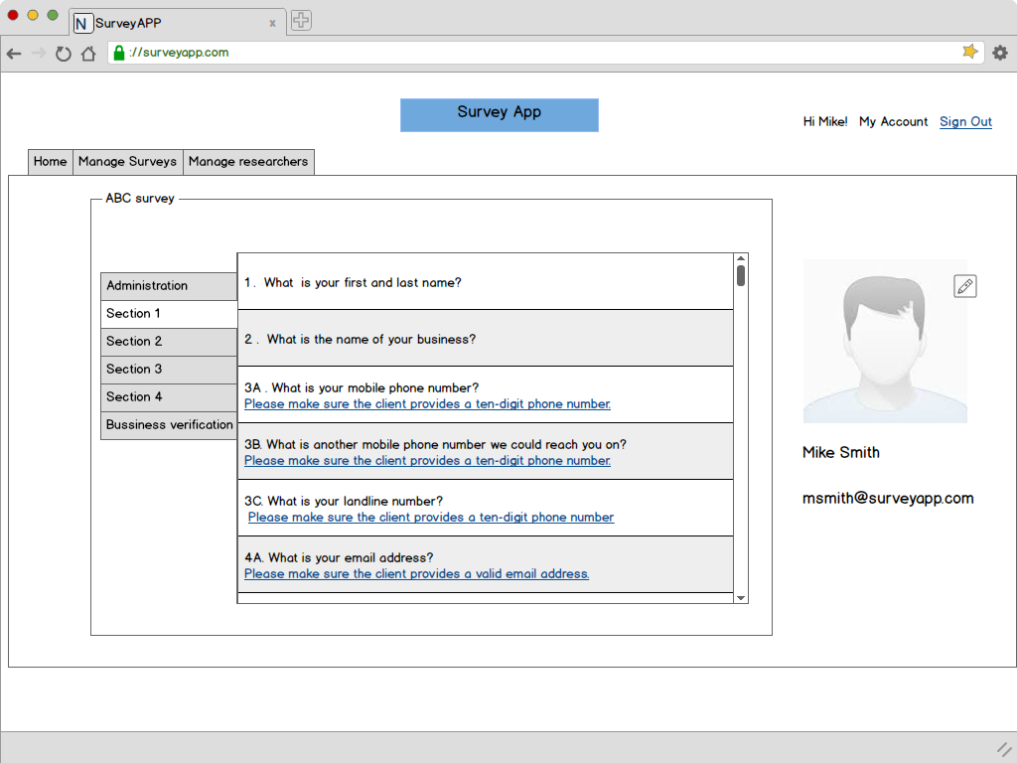

* View Survey – Shows the survey questions to the admin.

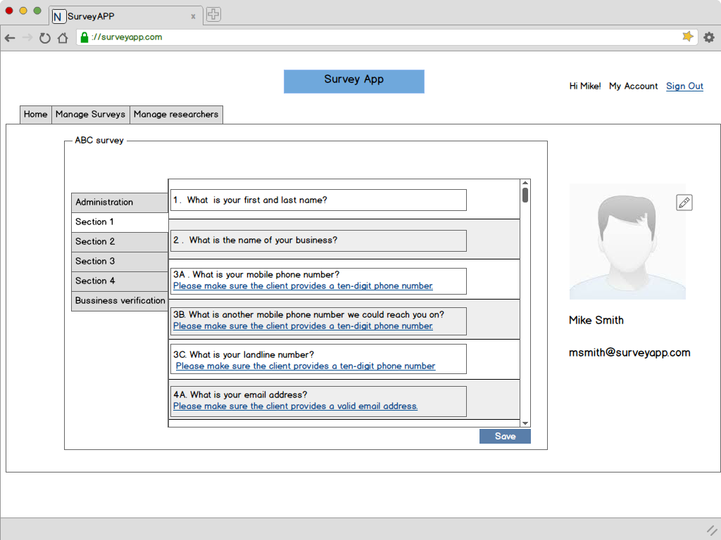

* Edit Survey – Allows admin to edit the questions of a survey. However the skip logic of the survey cannot be altered on the web end and will be taken care at the database end.

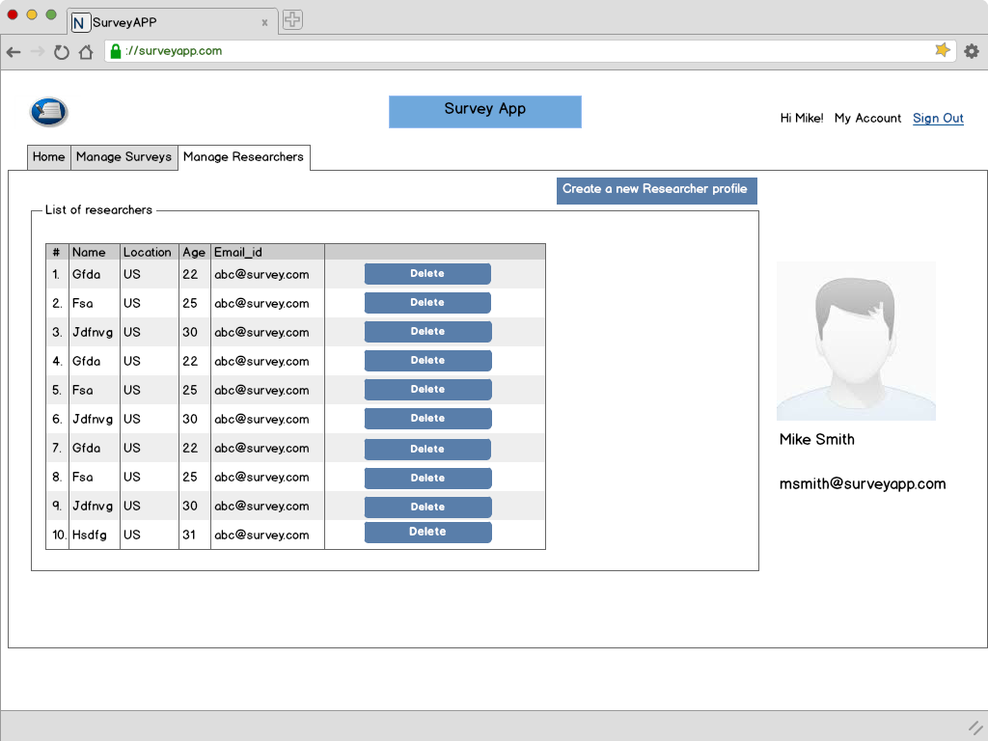

* Only the Admin will have the functionality to create/delete a researcher profile.

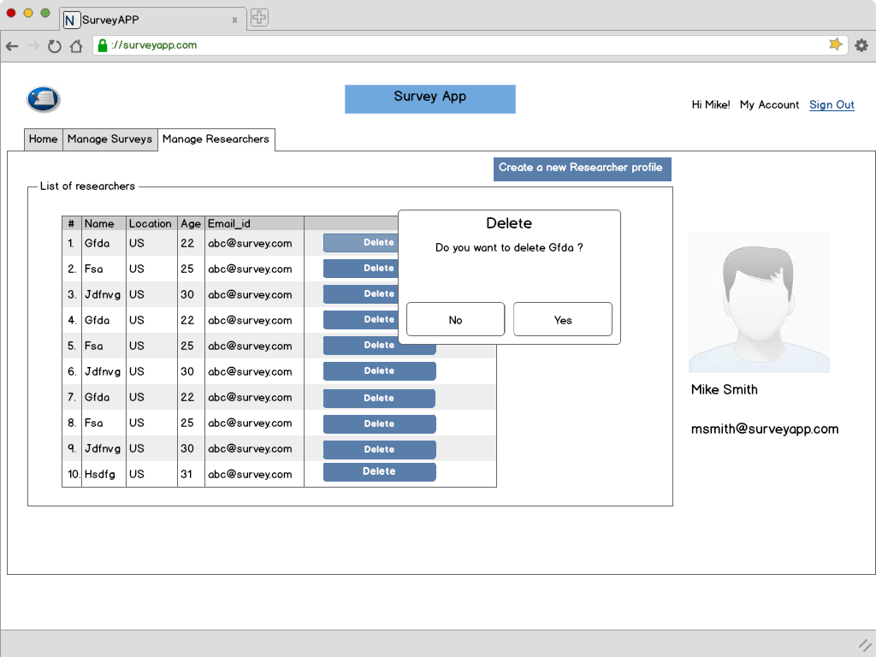

* Deletion of Researcher profile – The Admin will asked for confirmation before deletion.

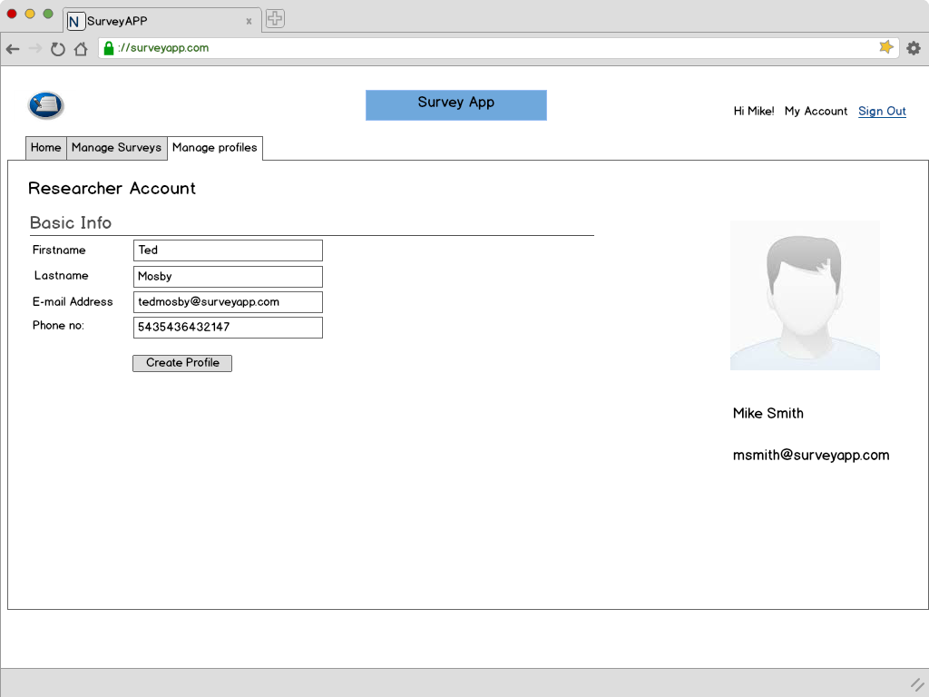

* Only the Admin can create a researcher’s account.
* Once the account is created, the researcher willl get an email at his email id with the username and password. They can use the same to login. However they will be asked to change their password the first time they login. This shall be the standard practice across all the new profiles.

**Researcher:** 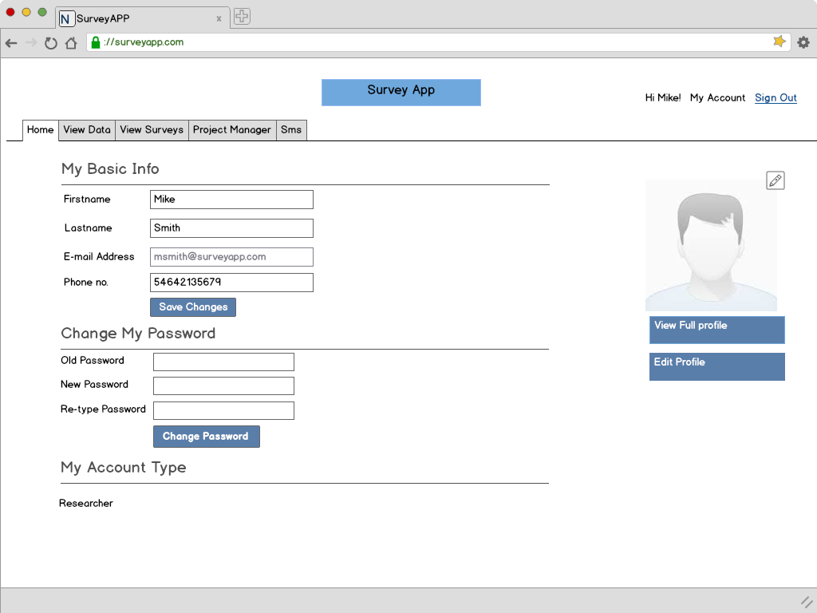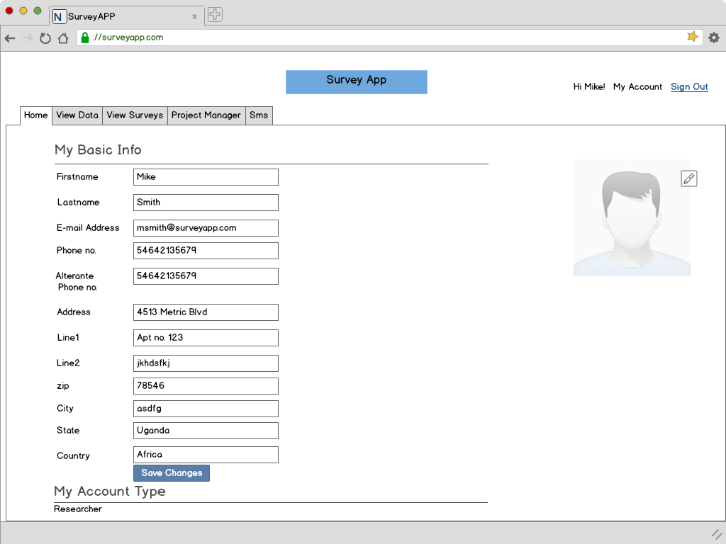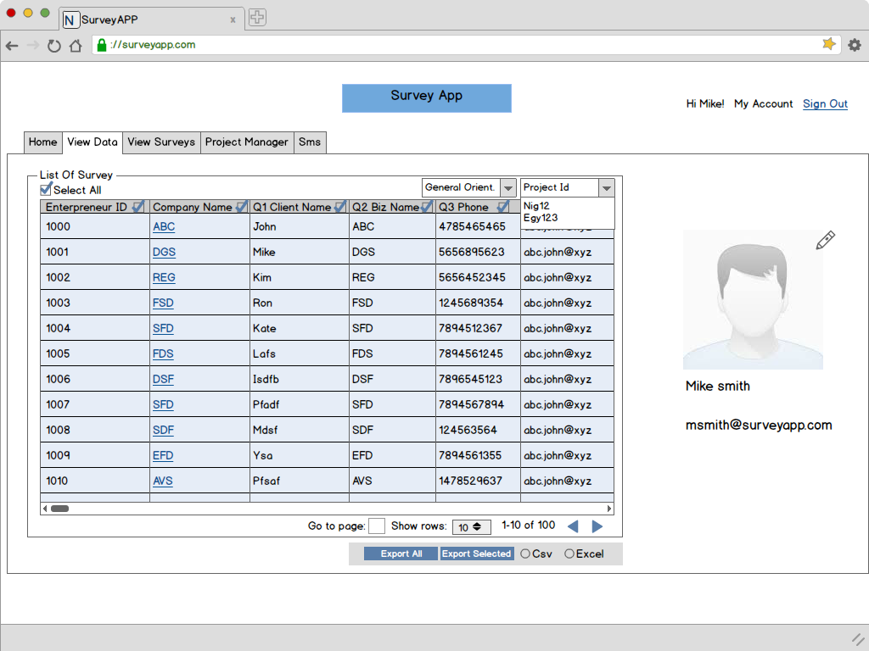

* View Data will allow the researcher to see all the survey data collected across geographies. They can export the data into relevant formats for offline usage.
* The Survey dropdown on top right above the table will allow the researcher to select the survey for which they want to see the data.
* The View Data tab will provide a display of selected surveys. The researcher can select the project id as well to segregate the surveys being displayed.
* The checkboxes provide with each column can be used to select which columns to be kept in the exported dataset.
* “Export All” button will allow the researcher to export the data for all surveys for all Entrepreneurs into a single output dataset. Any survey not conducted with a surveyor will have its field as ‘Null’.
* A click on the hyperlink in the company nase will take the researcher to the View Survey tab with the survey details displayed for the current survey.

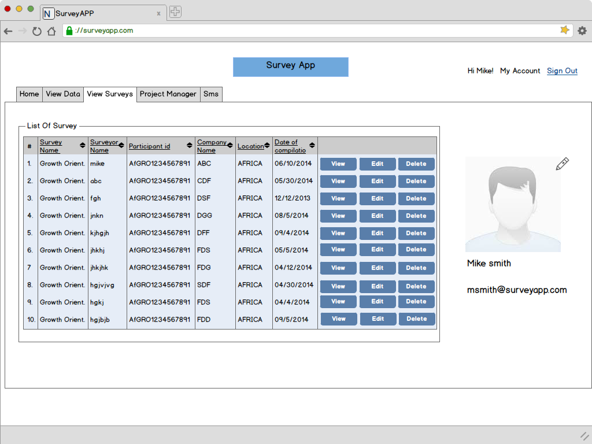

* View Survey will list out all the surveys. The researcher can view/edit any survey.
* Paging/scrolling will be implemented in the Table for ease of use.
* Delete functionality will allow the Researcher to delete any survey.

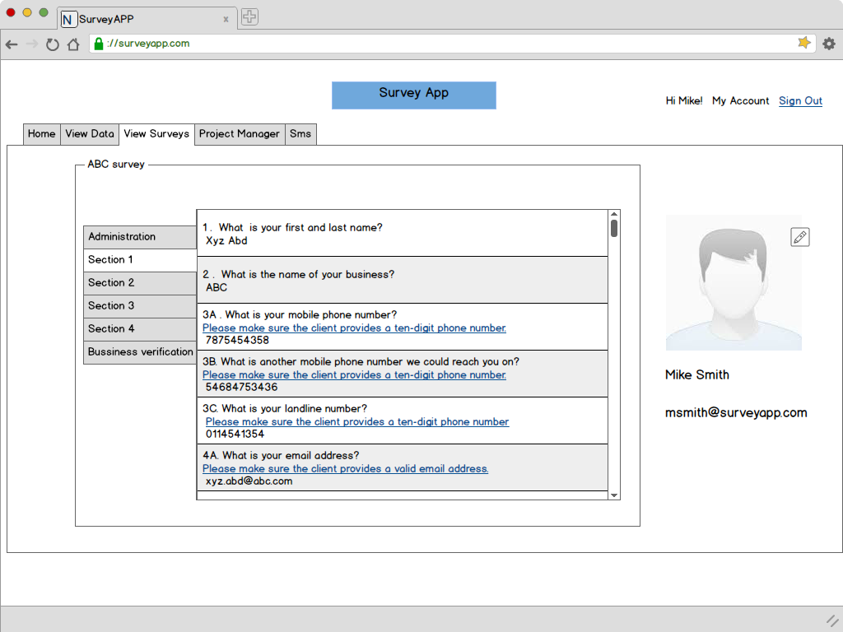

* The above screen will come up when the researcher clicks on “View” button for any survey.

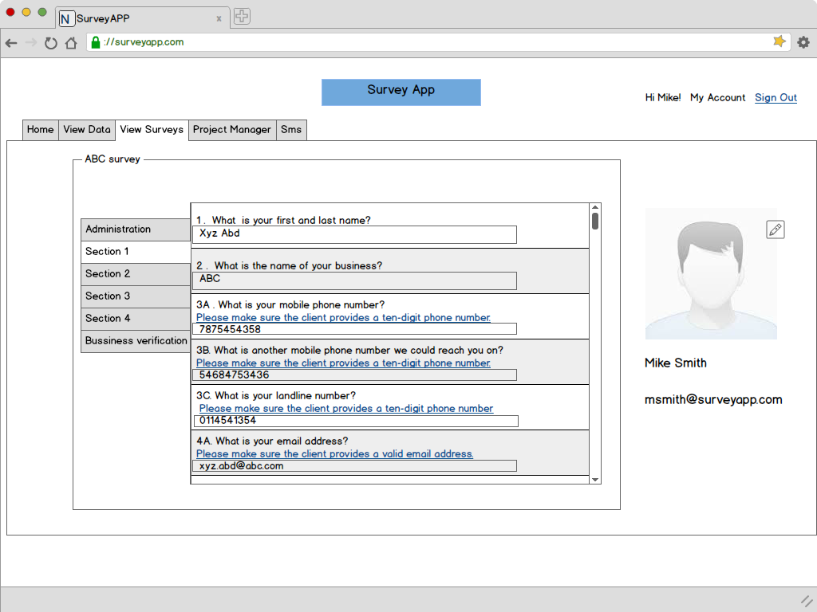

* Researcher can edit the survey data collected and update the same.
* The updated data will be saved as a new entry and will not overwrite the original data so as to track any updates that have been made to the surveys.  
  Each update will be saved with the current timestamp. When being picked up for viewing, the most recent update will be picked up for display.

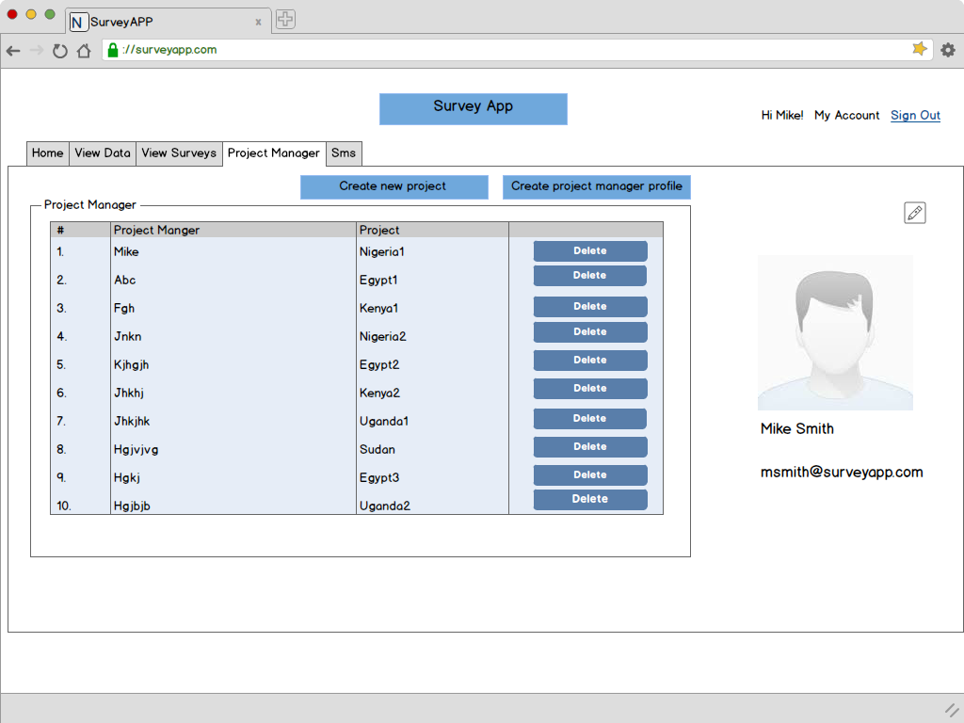

* The Researcher will be responsible for assigning different projects to Project Managers.
* This screen will display the list of different Project Managers and the projects assigned to them.
* Researcher will also be able to go to the screens where they can create new projects/project managers.

**Create project manager profile:**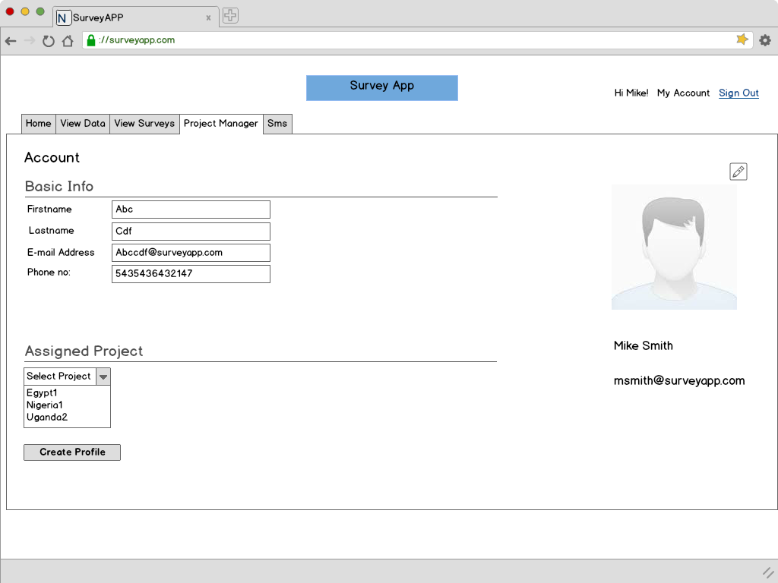

* Researcher can create a Project Manager’s profile from this screen and assign a project to him/her.

**Create a new project :**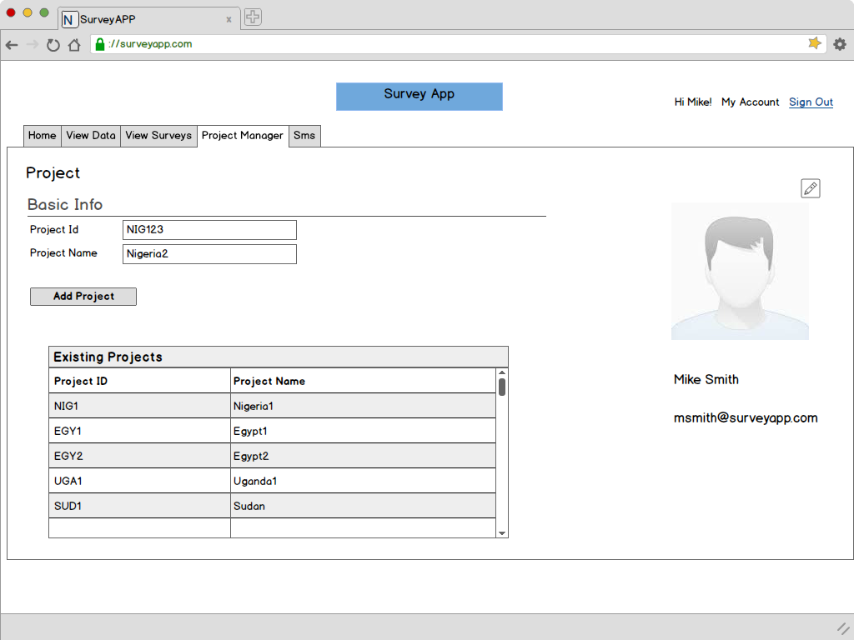

* Researcher can create new projects across different Geographies. Once created, these will be available for assignment in the Project Manager tab.

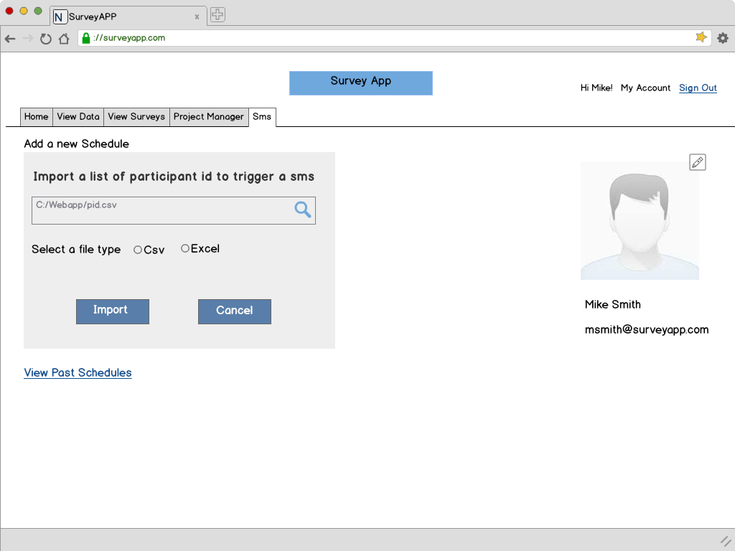

* Researcher will also have the flexibiity to create a schedule when the SMS schedule will triggered for the Entrepreneurs they want to send SMSes to.
* Researchers can upload a list of Entrepreneurs in CSV/ XLS format and import the same.
* These lists will be saved for viewing anytime later.

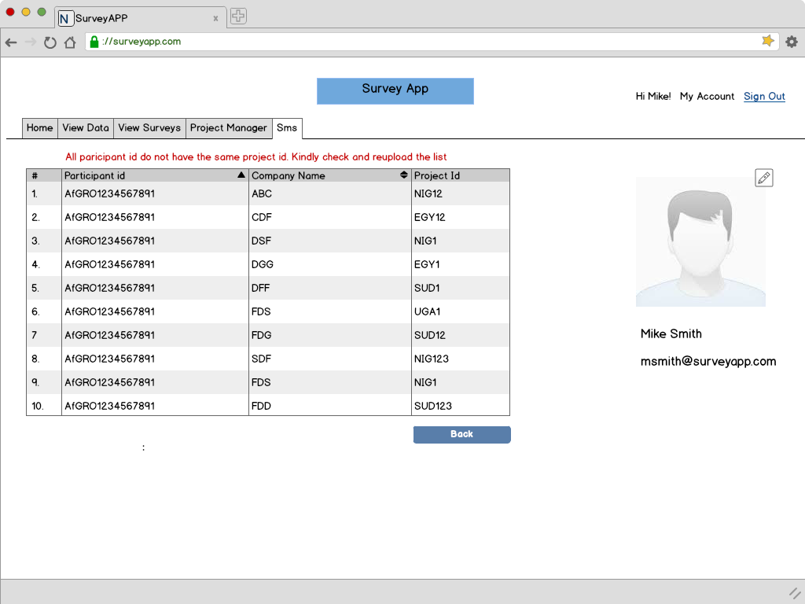

* In case all Entrepreneurs do not belong to the same project id, the system will not allow for the SMS schedule to be set.
* The researcher will be displayed the list of intended Entrepreneurs along with their Project Ids and error message.

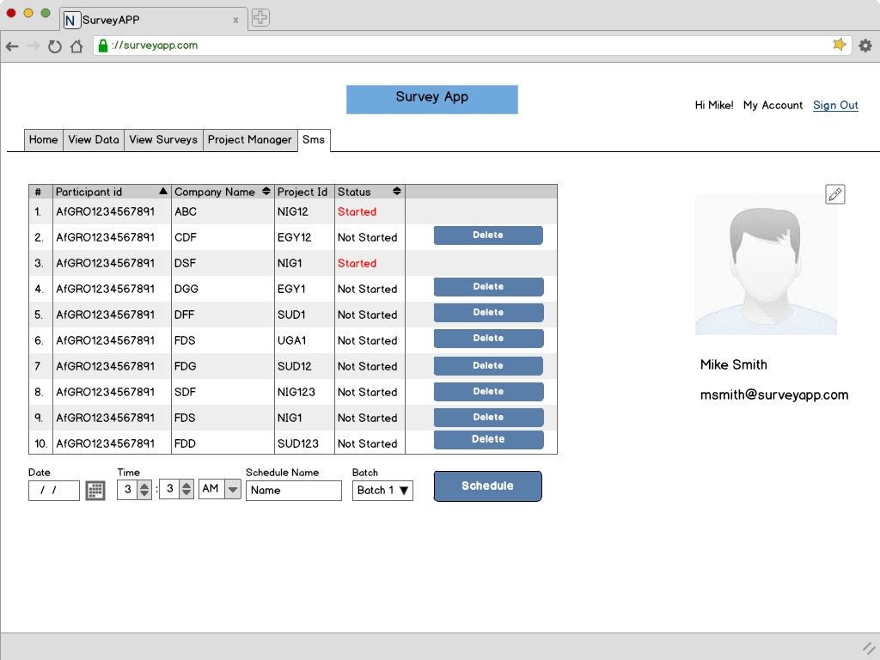

* Once the list of Entrepreneurs is imported, the system will highlight any Entrepreneurs who are already receiving the SMSes. These will not be included in the SMS schedule.
* Researcher can remove any Entrepreneur at this stage.
* The researcher will be asked as input the date and time when they want to trigger the SMS sequence and the batch they want to trigger.
* Once set, the schedule can be revisited from the SMS tab and the recipients removed from the list. However, once the SMS schdule has started, it cannot be altered.

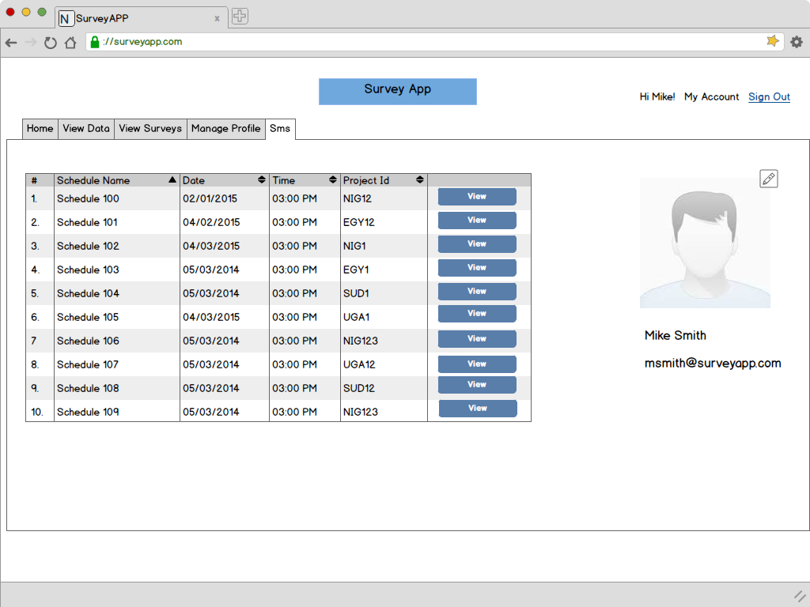

* This screen allows the researcher to view past SMS Schedules.

**Already Initiated Survey:**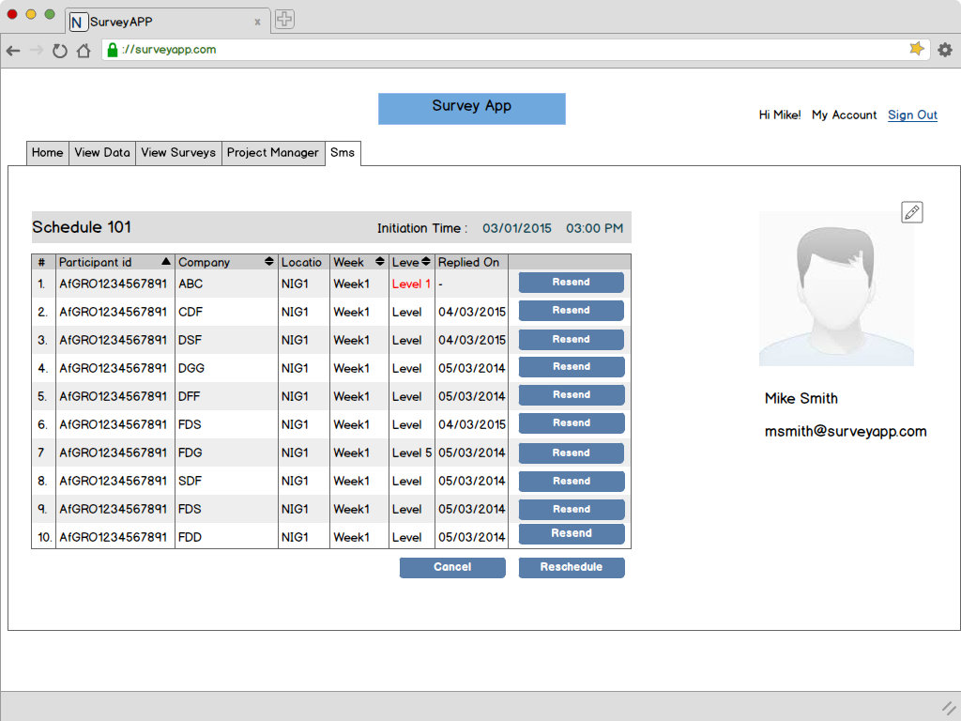

* The researcher can view the status of the SMS schedule for all Entrepreneurs in the schedule.
* The resend button allows the researcher to send the last SMS again to the Entrepreneur in case they are not replying.

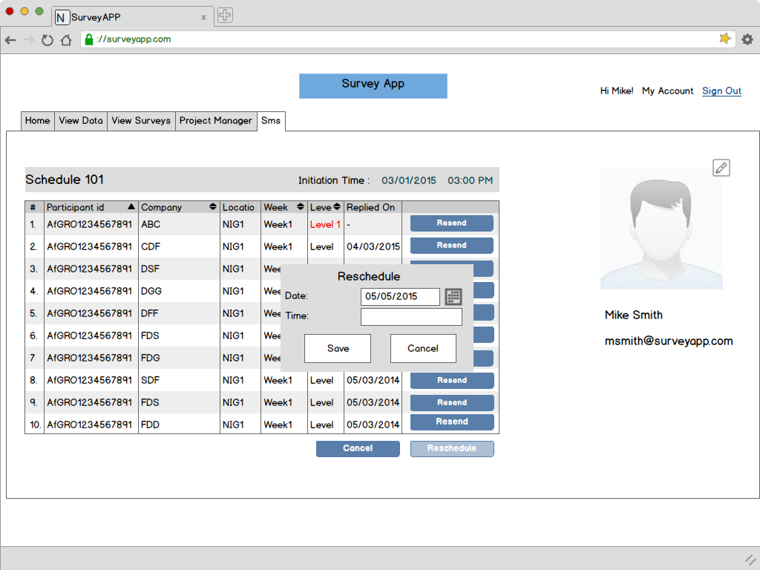

* The Researcher can reschedule a list. However that list must have finished off a complete batch of SMS before it can be rescheduled.

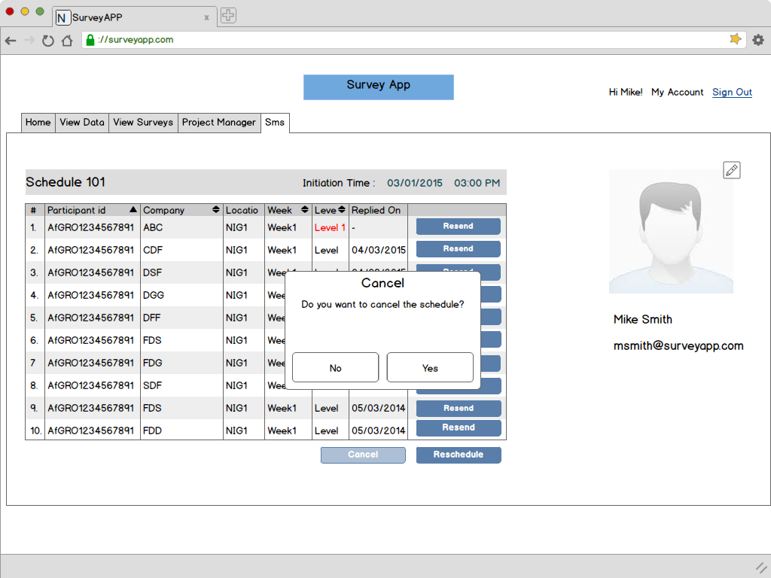

* The batch can be stoppped by clicking on Cancel and confirming the cancellation of the batch.

**Not yet Initiated:**

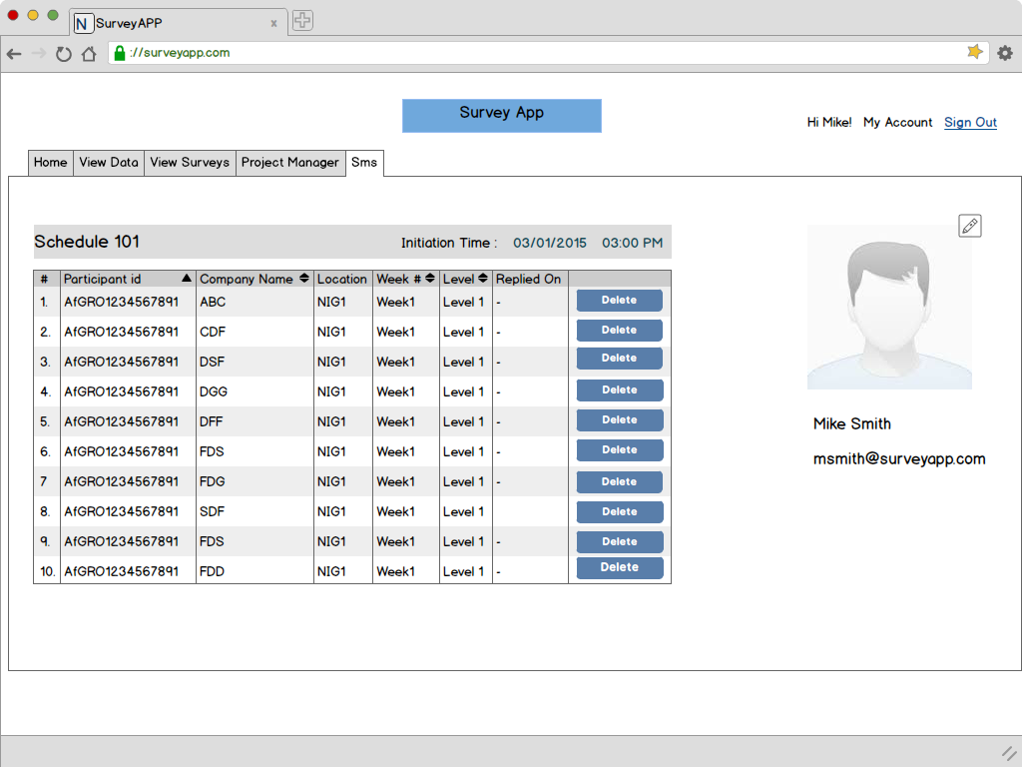

* In case the batch hasn’t started execution yet, the Researcher will be allowed to make changes to the SMS schedule.

**Project Manager:** 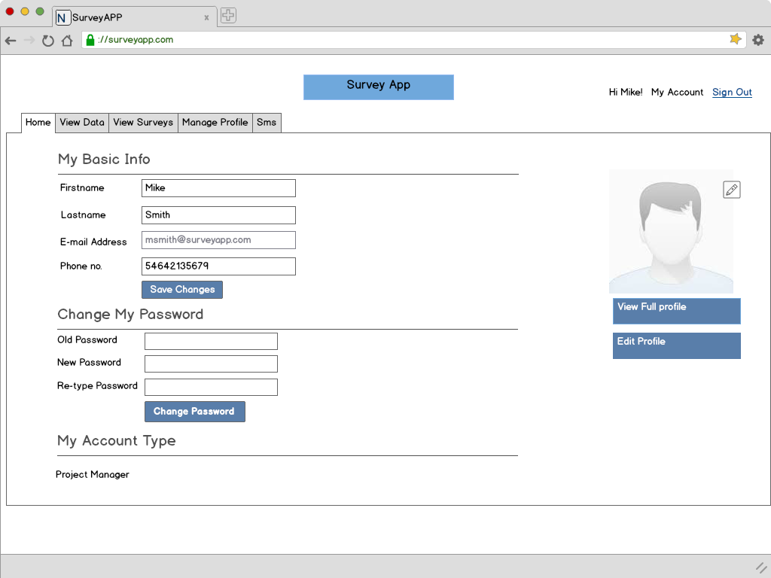

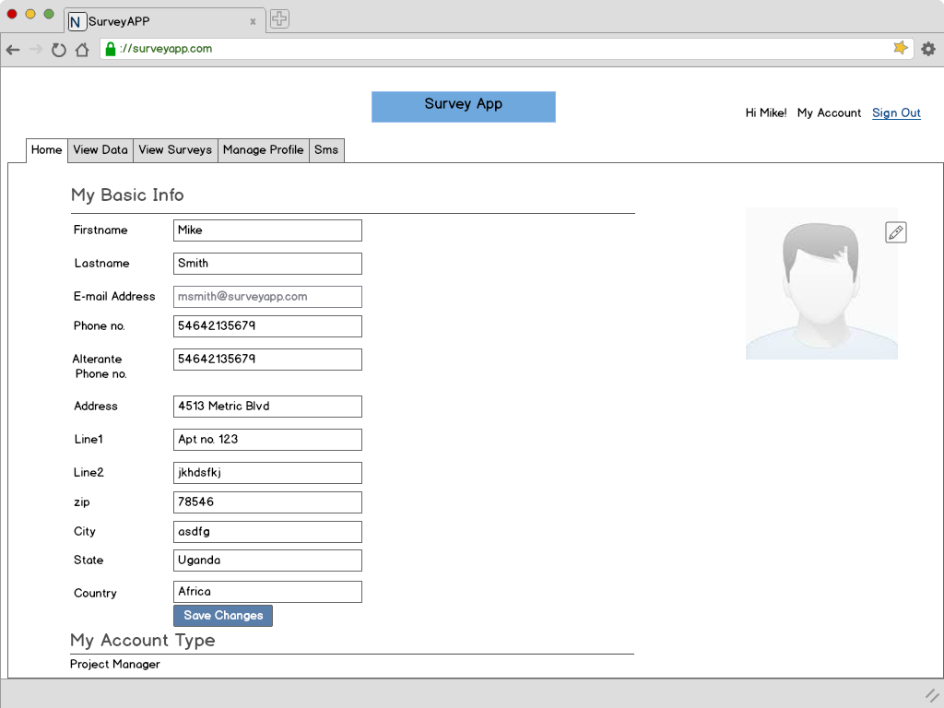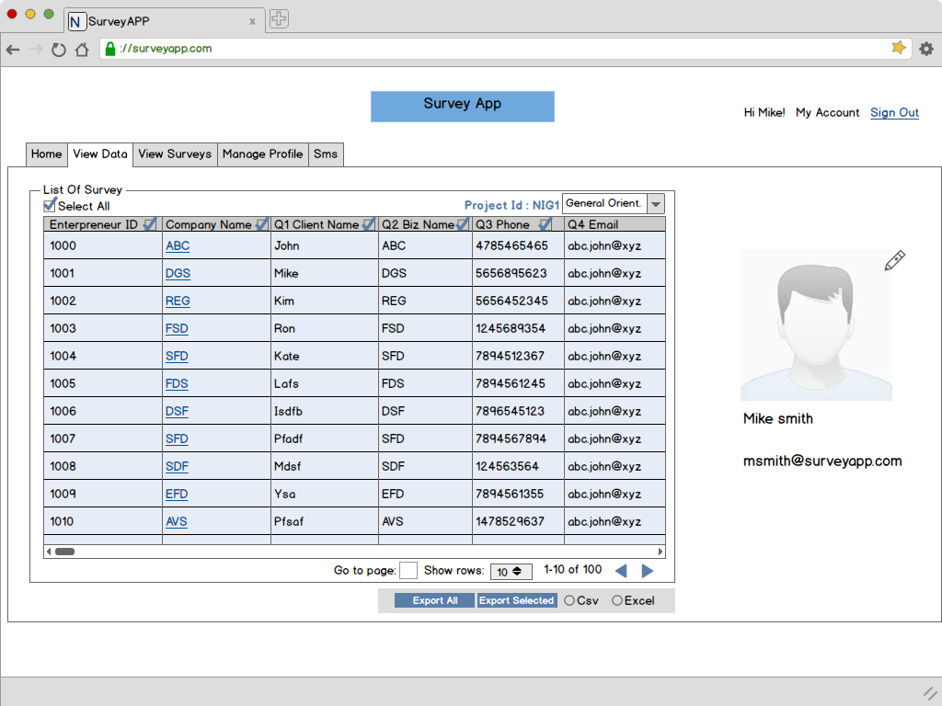

* View Data will allow the Project Manager to see all the survey data collected across his/her domain. They can export the data into relevant formats for offline usage.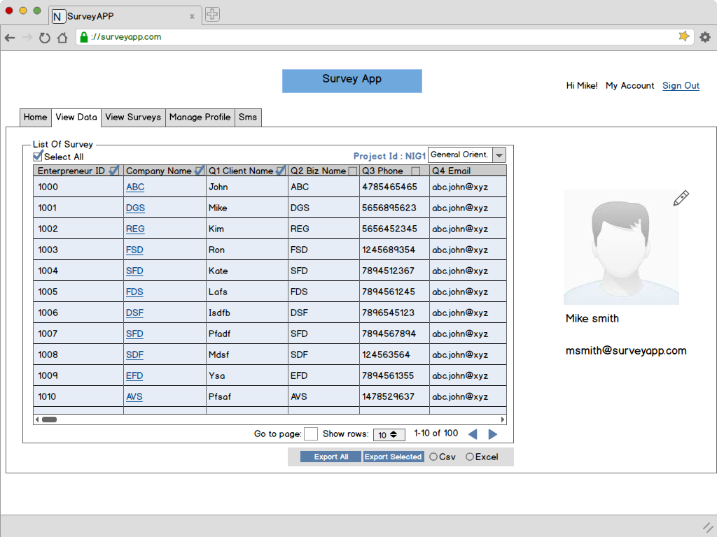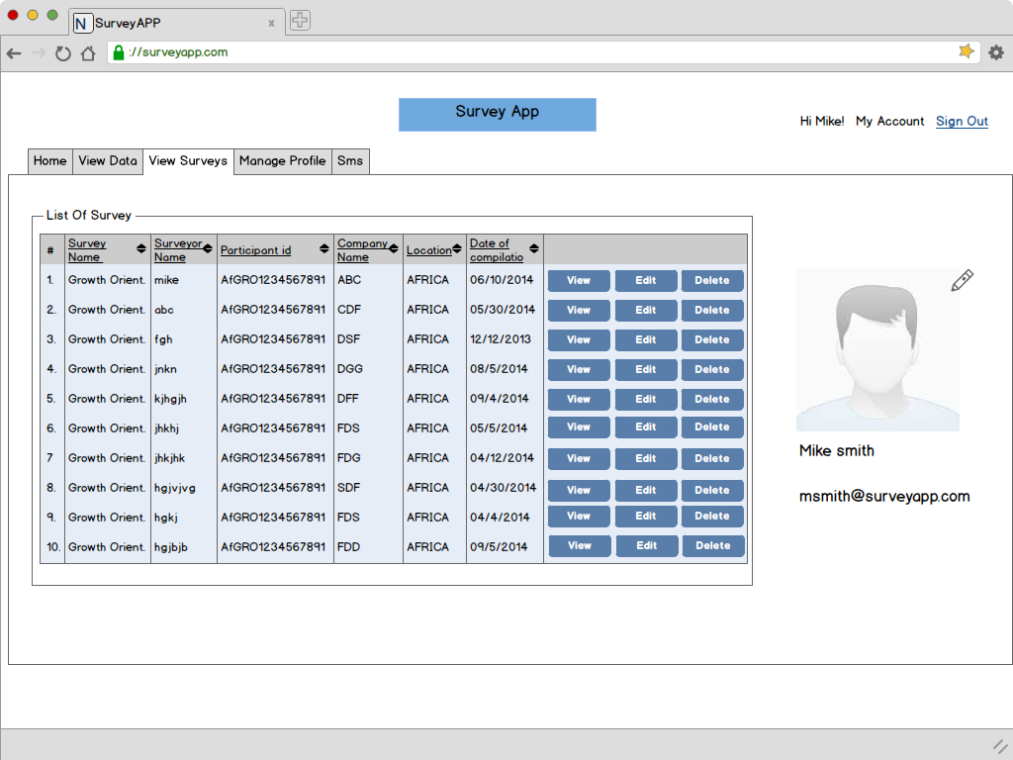

View Survey functionality will be implemented as in researcher.

* The only difference is that the PM will be able to view the surveys conducted by Surveyors in his/her project only.

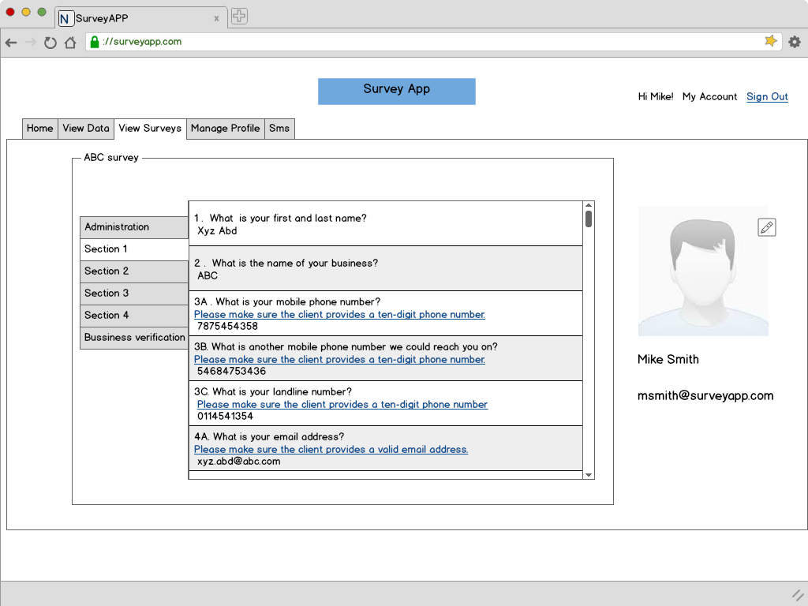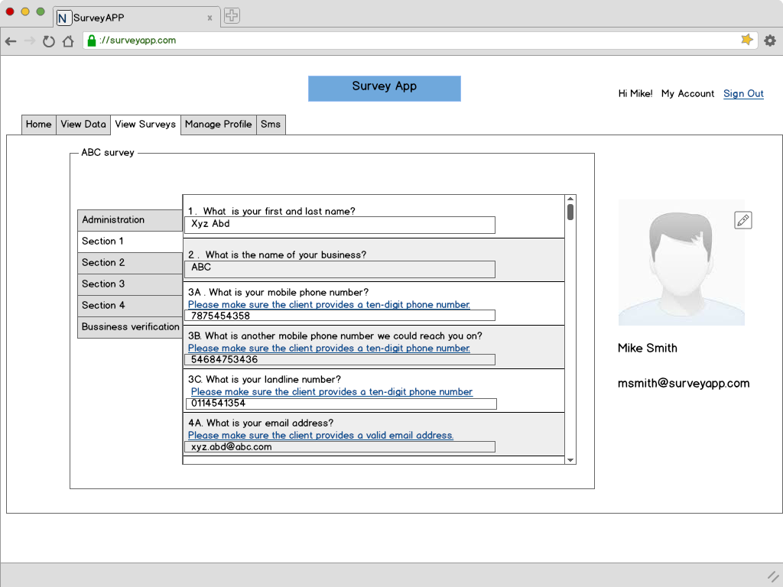

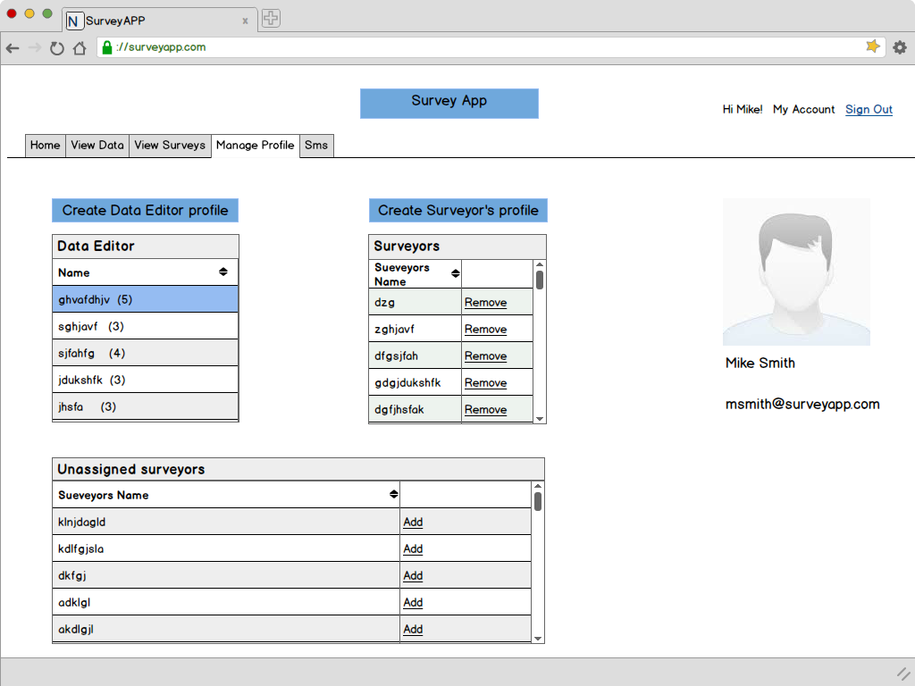

* The PM can assign different surveyors to a Data Editor.
* The assigned Data Editor will be responsible for verifying the surveys conducted by the Surveyor and flagging questions wherever deemed necessary.
* This screen will enable PM to move the surveyors around and assign them from one Data Editor to another.

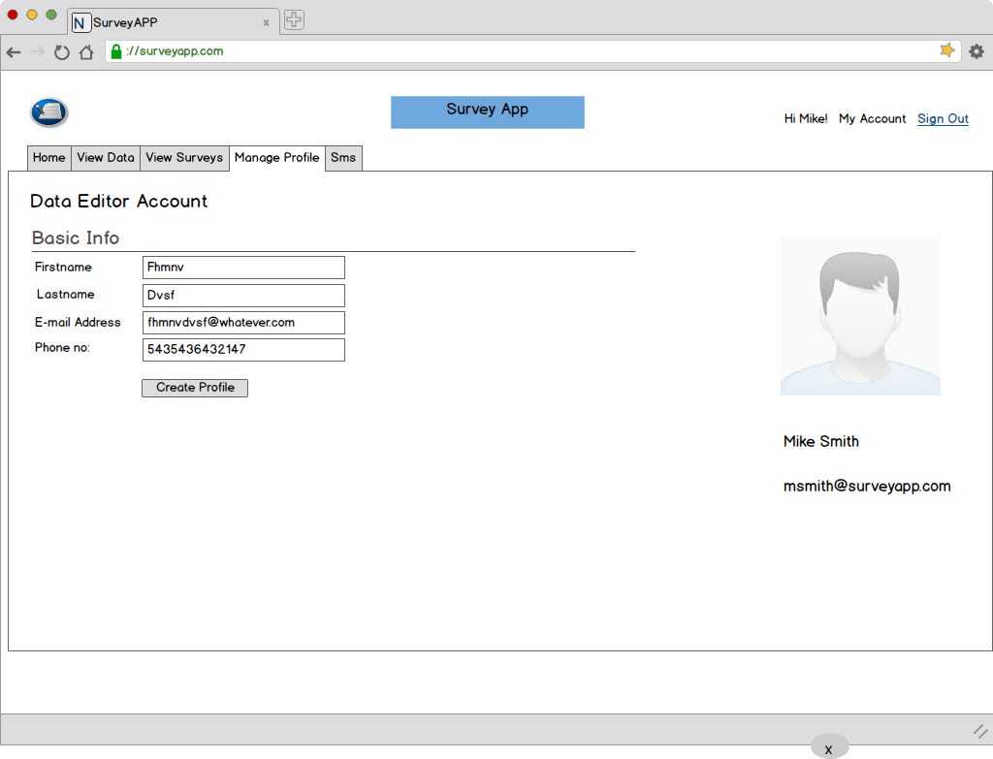

* Creation of a Data Editor’s account.

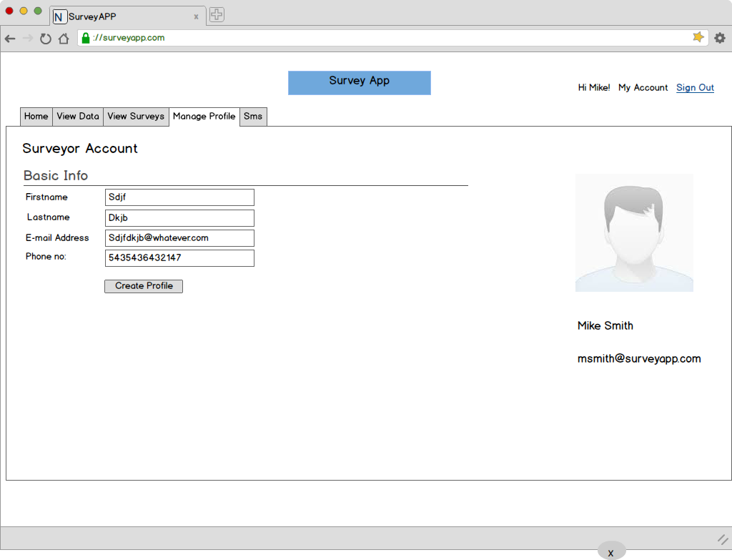

* Creation of a Surveyor’s account.
* The authentication mail of a Surveyor will go to the the Project Manager who will responsible for creating an account for the Surveyor.
* The password will be communicatd to the Surveyor by the PM.

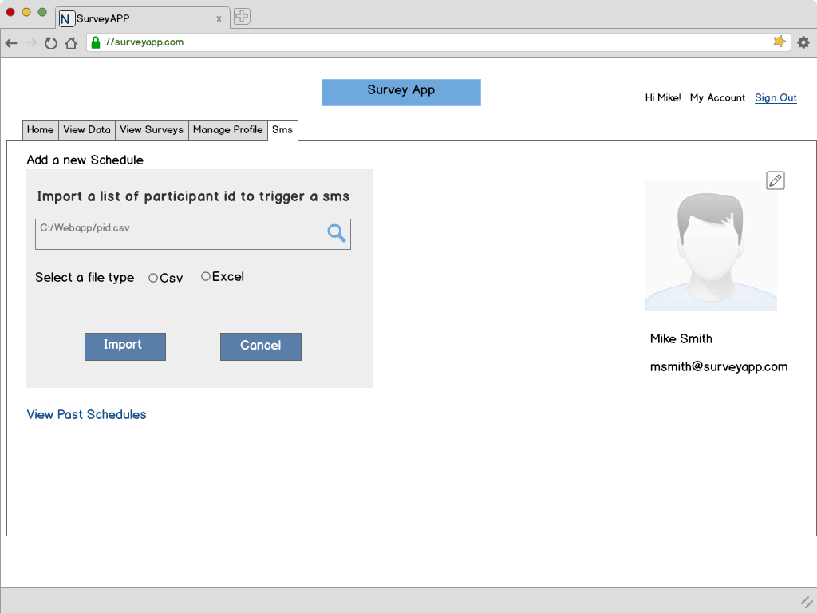

* The SMS module will perform as it does for the researcher.

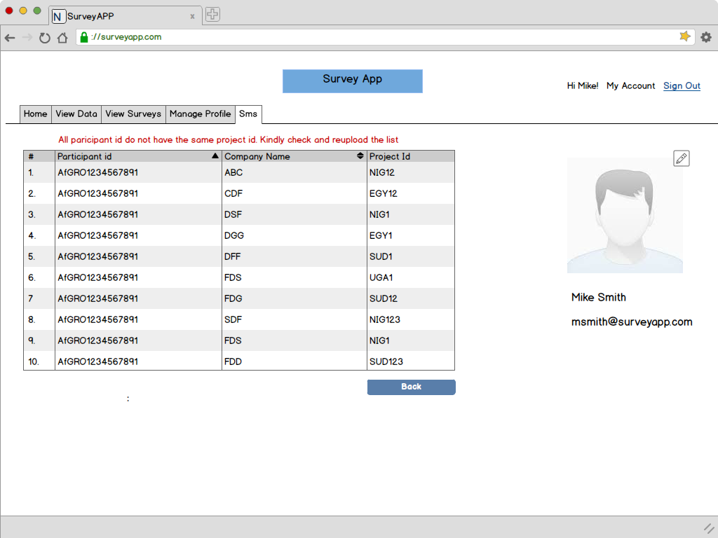

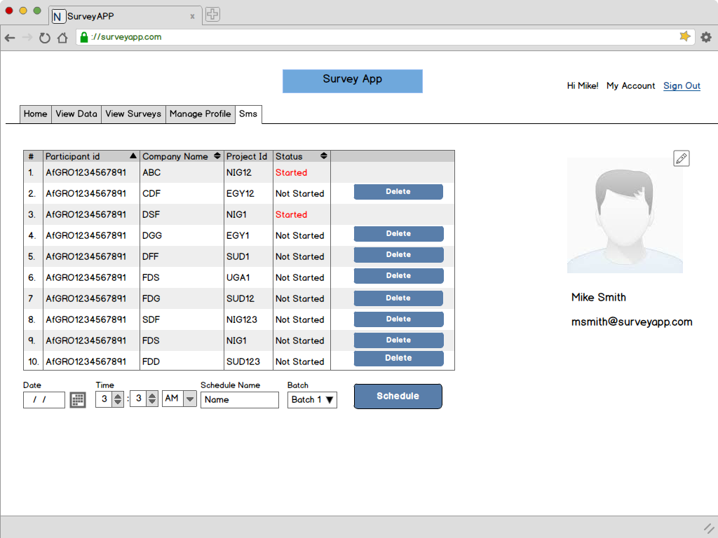

* Project Manager will be able to see the schedules corresponding to their project only.

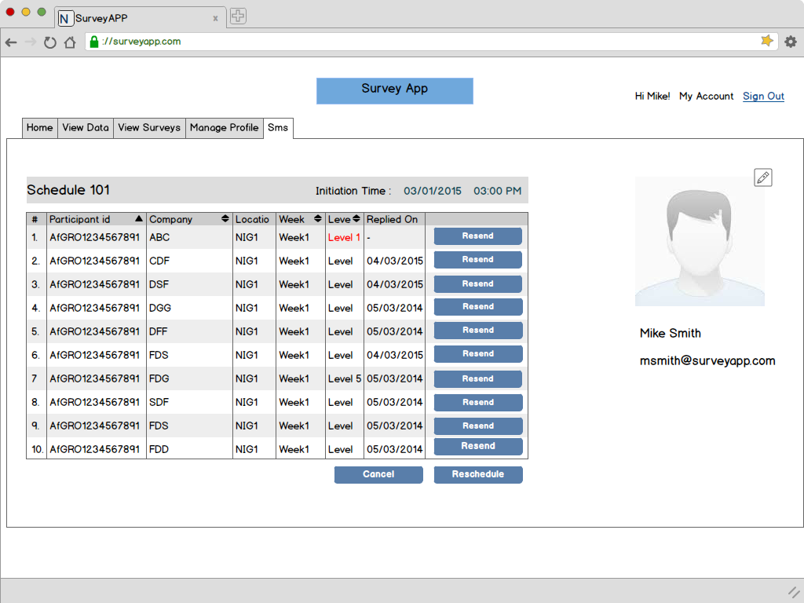 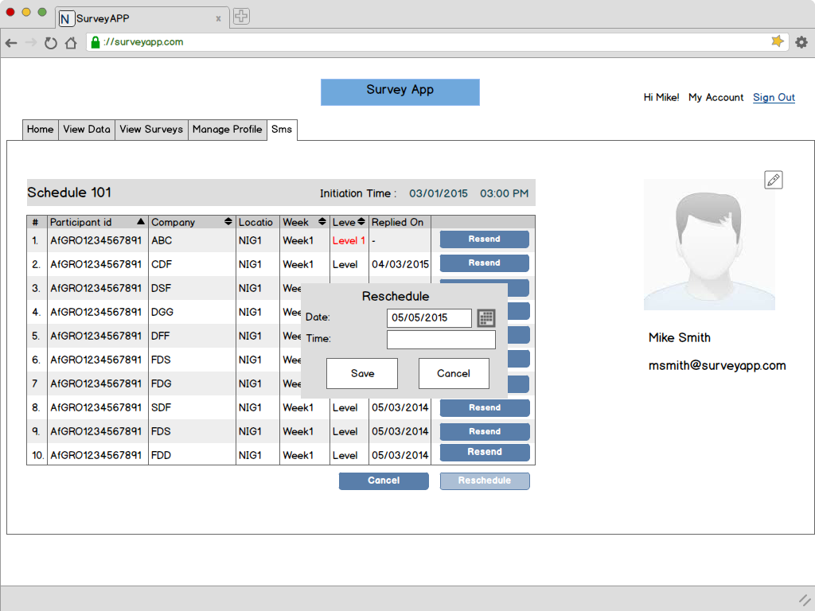­­­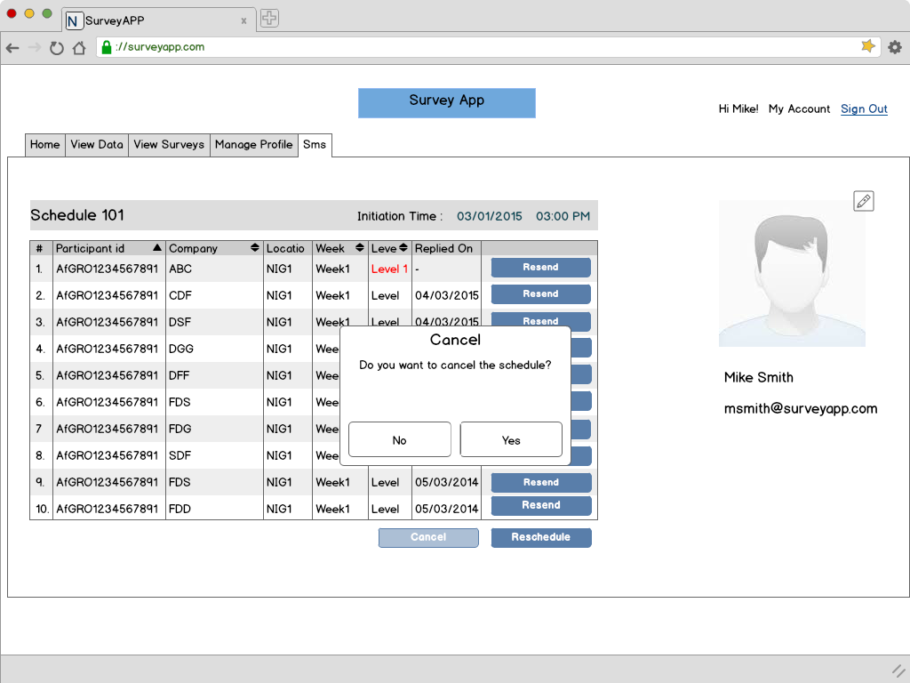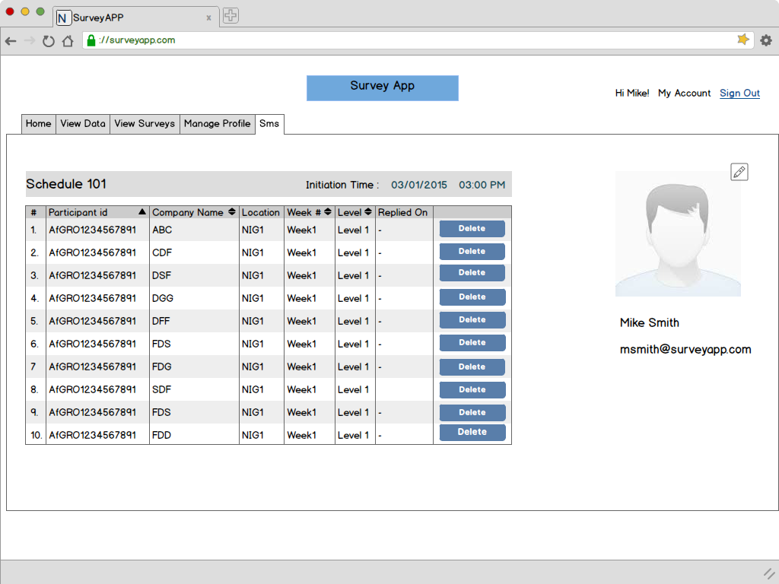

Last level respond date

**Data Editor:** 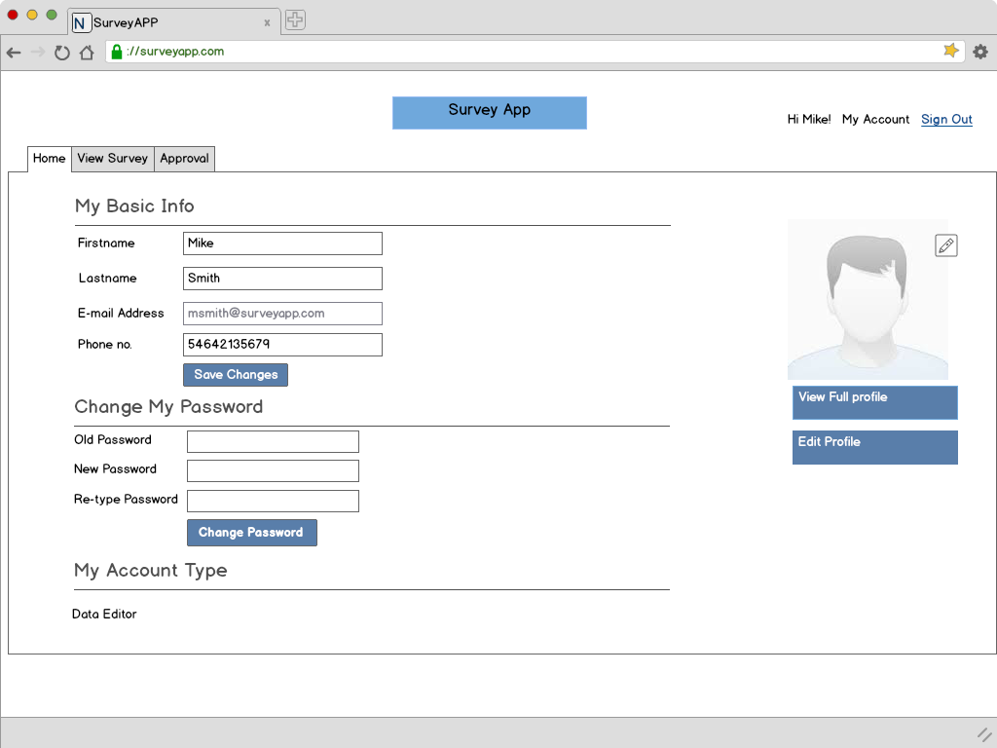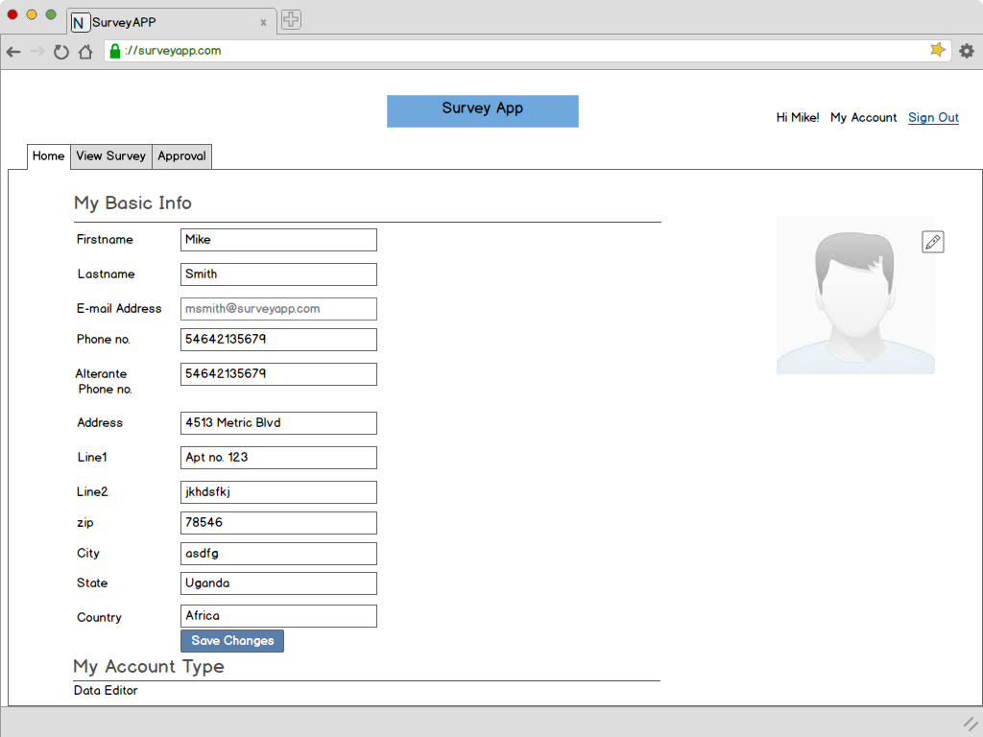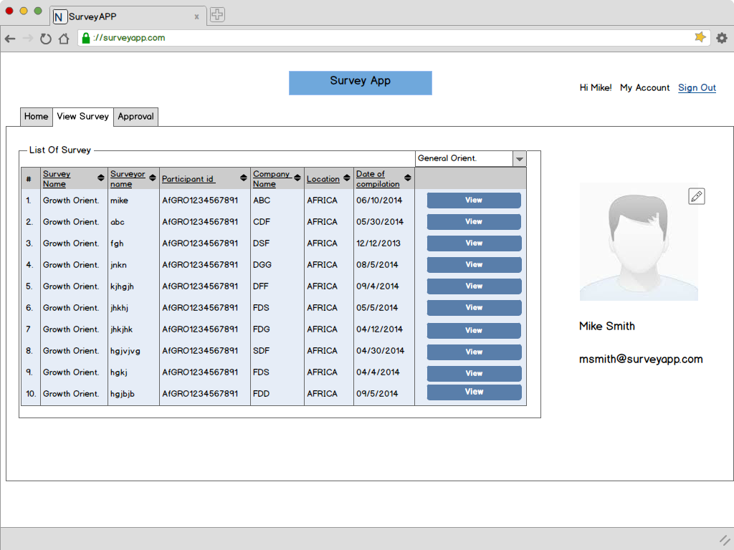

* Data Editor can view all surveys conducted by the surveyors assigned to them. However they cannot edit the survey data.

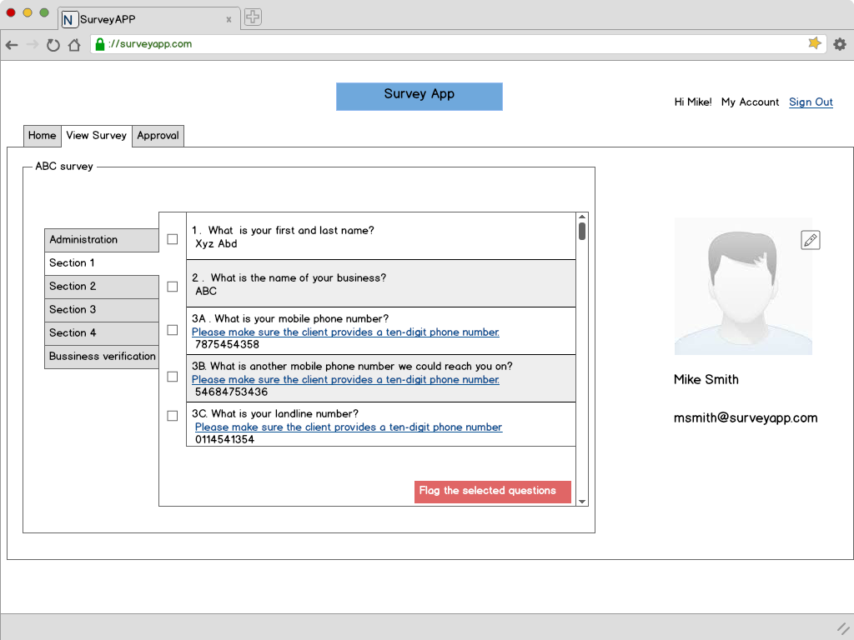

* Data Editor in the View Survey tab can flag the questions that they deem inconsistent.
* They can keep on flaging questions in the entire survey and the press “Flag” button.
* Surveys oncee flagged cannot be altered by the Data Editor.
* The flagged questions will come up in a surveyor’s mobile device and will have to be recollected by visiting the Entrepreneur.

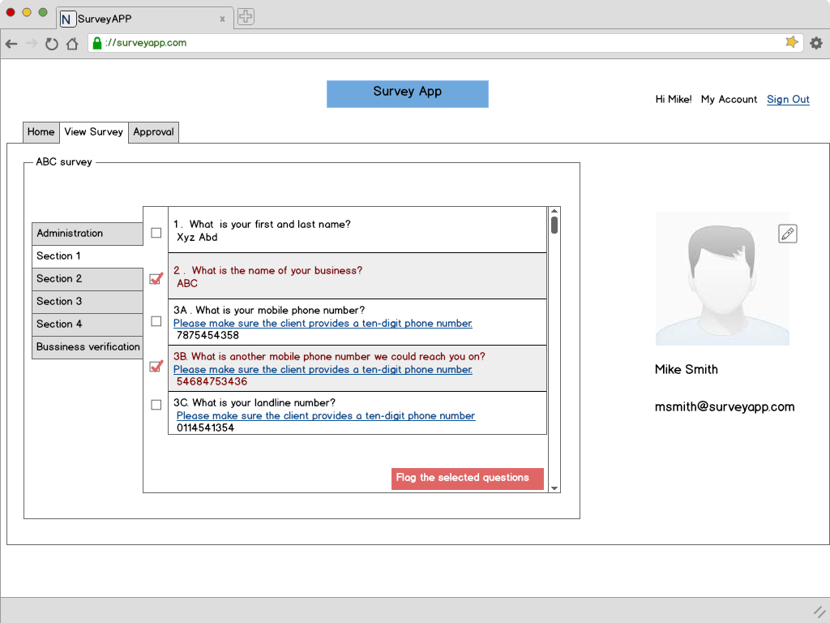

* Once a question has been flagged, it can not be undone and will automatically get synced to he Surveyor’s tablet for recollection.

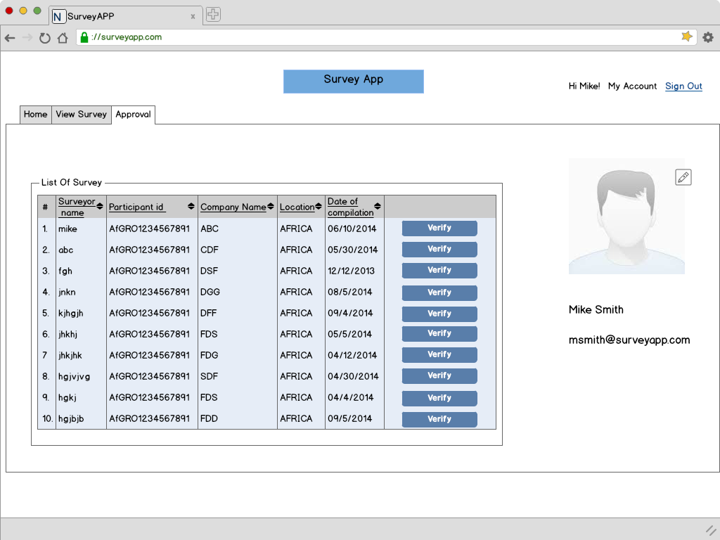

* The questions verified by Surveyor will come up in the Approval tab.
* The Data Editor can view the recollected data and approve the changes if he/she finds them appropriate.

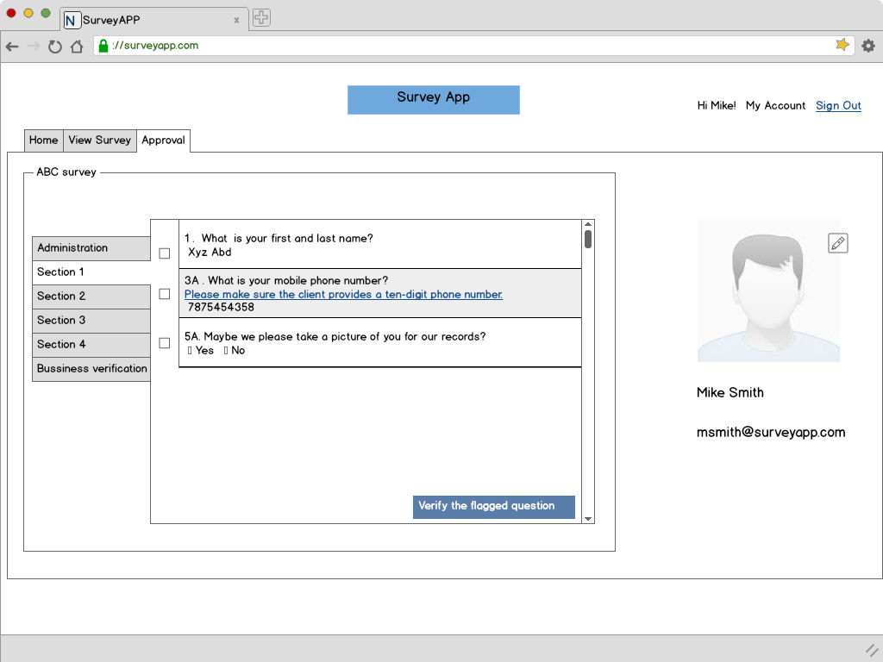

**Entreprenur:** 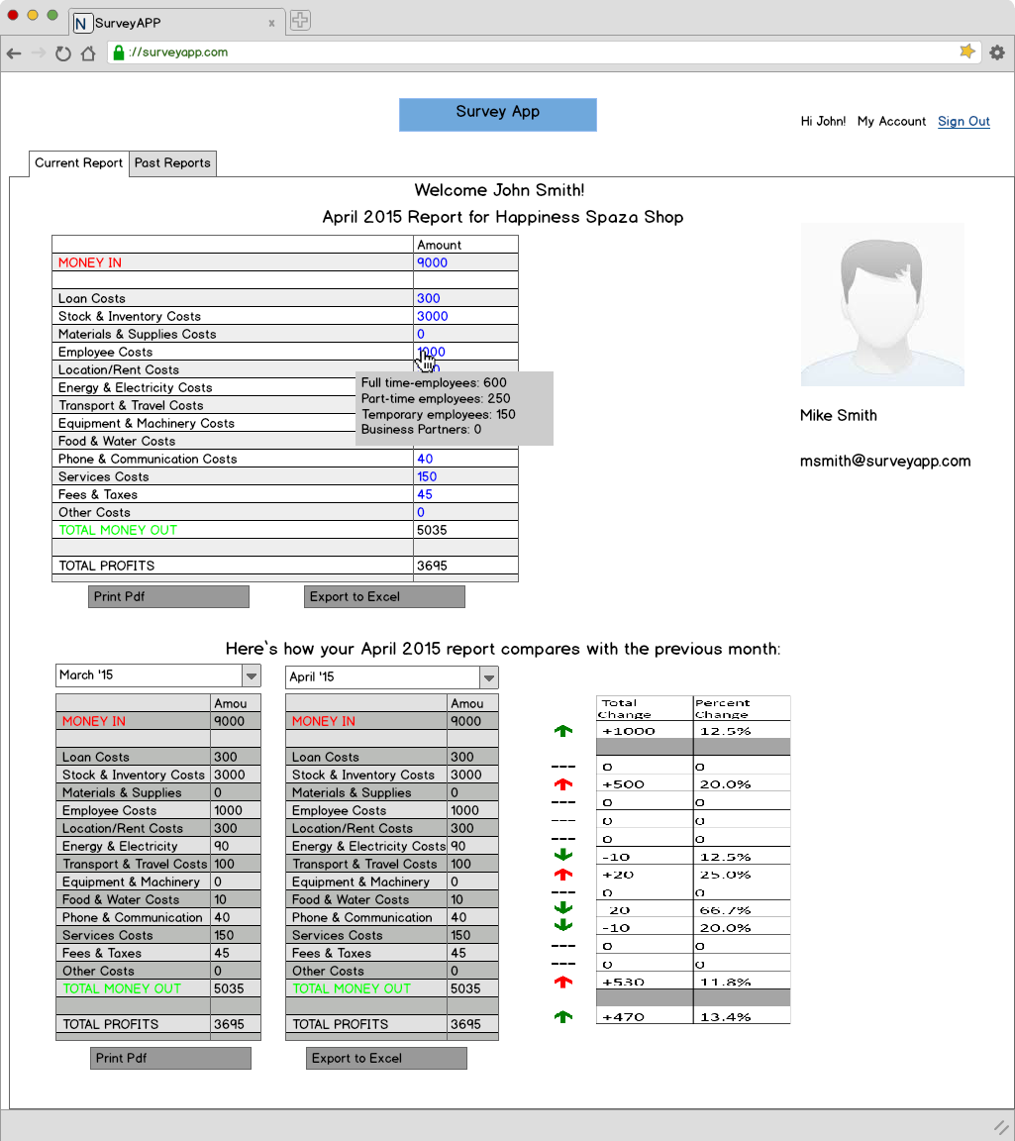

* On Login the Entrepreneur can see the report which will include the following:
  + This is your [Month/Year] report for [Business name].
  + This is how your [Month/Year] report compares with the previous report.

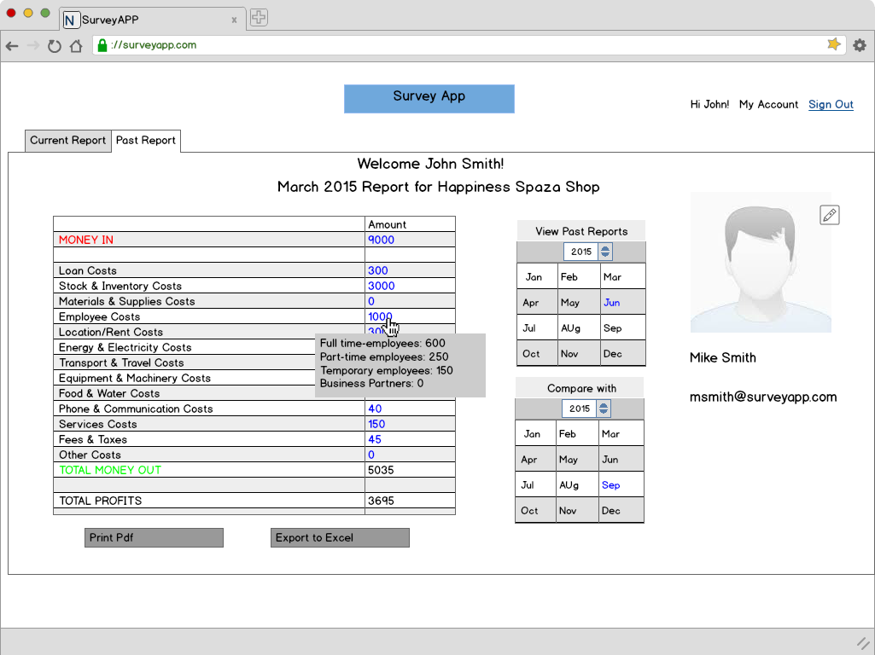

* In the past report tab, the Entrepreneur can view reports based on previous month’s feedback and also compare it with other month’s data.

**Comparision of 2 months**

